|  |  |
| --- | --- |
|  | **Sri Lanka Institute of Information Technology**  **TMP-22-157** |

Project Topic Assessment – 2022 (Regular)

Topic

Identifying Diseases, Pests, and Weeds that harm Rice crops as well as finding the appropriate fertilizers with the inclusion of information ontology / with the inclusion of a chat bot using Image Processing and Machine Learning

Abstract (200 Words Max):

In our country of Sri Lanka, Rice is the most common type of food that is consumed in a daily basis. Due to that there is a huge amount of stress on Rice farmers to supply according to the massive demand. All the while they are currently farming in poor conditions such as Diseases and Pests that harm rice crops with the inclusion of weeds that plague the field. They also have difficulties finding the correct fertilizers and the amount that are needed for the crops to grow.

We chose those topics due to these statistics found below.

* Losses due to all insects= 34.4%
* Losses due to all diseases= 9.9%
* Losses due to all weeds= 10.8%
* Potential production harvested= 44.9%
* Total potential production lost before harvest= 55.1%

We aim to develop a mobile application to help farmers with these problems using Image Processing to analyze crops and find solutions situated at an online cloud database, to finally issue suggestions with Machine Learning.

Ontology –and most of the farmers are not up-to-date with the newest technologies and methodologies

And we hope to enhance the accuracy of our data using online data sources

Chat bot - and most of the farmers are not up-to-date with the current prices and store locations that rice are sold.

Research Group/Area: Select the area by referring to the document uploaded to the Course Web

Machine Learning and Soft Computing (MLSC)

**Machine Learning (ML)**

**Supervisor should fill this part**

Continuation of Previous Year Project?

Supervisor and Co-Supervisor endorse the proposed project, and hence, guide the students to acquire required knowledge skills pertaining to above sub domains of their specializations.

Supervisor: **Select Supervisor**

If yes, state the Project ID

and year

Co-Supervisor: **Select Co-Supervisor**

Signature

External Supervisor

Name

Team Members:

|  |  |  |
| --- | --- | --- |
| Student Name | Student ID | Specialization |
| Leader: Salika Madhushanka W.J | IT19101620 | SE |
| Member 2: H.H.W.M.Binuka sihan paranagama | IT19129372 | SE |
| Member 3: P.Y.D Jayasinghe | IT19117256 | SE |
| Member 4: K.M.Umesh Ranthilina | IT19240152 | SE |

Research Problem:

* The first major issue when it comes to rice is the prevalence of Diseases that are native to Rice. With new diseases and sicknesses being found each passing day, it becomes difficult for the common farmer to identify and treat them on their own. Pests and other unwanted insects are also attracted to the crops. These pests might be the reason that diseases are created from the plant as well as the reason to those who distribute them. They themselves, even while not spreading disease, might make the Crops unsanitary for human consumption[1].
* The second issue is the growth of unwanted Weeds that absorb the nutrients from the paddy fields that should have gone to rice crops[2].
* The third problem we have found is the Fertilizer distribution and identification being difficult for the common farmer [3].

The final problem farmers are facing is the lack of knowledge regarding the current market prices and the locations of the markets themselves.

[1]Rahman, C., Arko, P., Ali, M., Iqbal Khan, M., Apon, S., Nowrin, F. and Wasif, A., 2021. Identification and recognition of rice diseases and pests using convolutional neural networks. Available: https://www.sciencedirect.com/science/article/abs/pii/S1537511020300830. [Accessed March. 3, 2020].

[2]Wang, A., Zhang, W. and Wei, X., 2021. A review on weed detection using ground-based machine vision and image processing techniques. Available: https://www.sciencedirect.com/science/article/abs/pii/S0168169918317150. [Accessed February. 5, 2019].

[3]Xu, X., He, P., Yang, F., Ma, J., Pampolino, M., Johnston, A. and Zhou, W., 2021. Methodology of fertilizer recommendation based on yield response and agronomic efficiency for rice in China. Available: https://www.sciencedirect.com/science/article/abs/pii/S0378429017302861. [Accessed February. 11, 2017].

Solution proposed:

In order to overcome the research problem, the team will propose a mobile application that uses Image processing and Machine learning.

* For the first issue above mentioned, the farmer will first take a picture of the affects crops and the application will give details about the condition and how to treat them.
* For the second issue, after the farmer has taken a picture of the crops the weeds will be identified and how to safely remove them will be shown.
* For the third issue, after identifying the type of rice the appropriate fertilizer and the amount will be given.
* For the final issue, we are proposing a Chat Bot to find current market prices and nearby locations of stores for farmers

System Overview Diagram for the solution proposed. Recommended to draw using [draw.io.](https://app.diagrams.net/) Note: This is not an activity/flow (UML) diagram

1. **Man components including the data sources, stakeholders, interaction among the stakeholders, etc.**
2. **Interconnection among the components**
3. **Major SW and HW components**

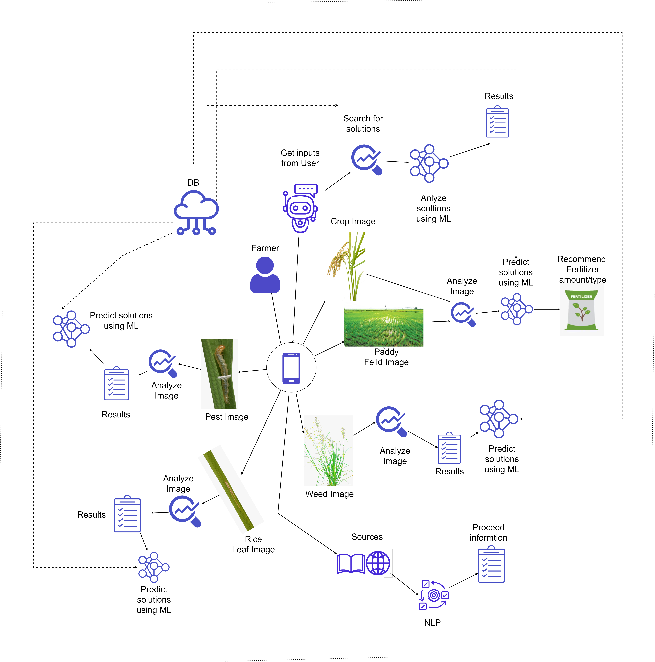

Objectives (1 main objective and 4 sub objectives):

**Main Objective:**

To help farmers with their paddy fields and make life easier for them.

**Sub Objective 1: Identify Pests and Diseases**

**Sub Objective 2: Identify Weeds**

**Sub Objective 3: Identify Fertilizer**

**Sub Objective 4: Information extraction using ontology / chat bot for easy information.**

Task divided among the members

Member 1

Detection of Pests and Diseases using Image Processing and finding solutions using Machine Language.

Member 2

Detection of weeds using Image Processing and finding solutions using Machine Language.

Member 3

Identification of fertilizers according to the type of crop and quantity using Image Processing and Machine Language.

Member 4

Using ontology, extracting further information from internet sources with Natural Language Processing.

Using Machine Language creating a chat bot to give information about nearby stores and market prices

Technologies to be used:

Android (Java)

Python

Cloud Database ()

Machine Learning

Image Processing

Natural Language Processing

If supervisor States that this year is a continuation of previous work, state the further work the students should do compared to the previous years.

(NOTE: This part has to be filled by the supervisor)

If supervisor States that this year is a continuation of previous work, state the further work the students should do compared to the previous years.

(NOTE: This part has to be filled by the supervisor)

**This part will be filled by the Topic Screening Panel members**

Acceptable: Mark/select as necessary

|  |  |  |
| --- | --- | --- |
| Acceptance/  Rejection | Correction State | |
| Minor Correction | Major Corrections |
| Accepted |  |  |
| Resubmit |  |  |
| Rejected |  | |

Corrections (if necessary)

Major changes proposed: ____________________________________________________________________________________________________________________________________________________________________________________________________________________________________________________________________________________________________________

Any other Comments: _________________________________________________________________________________________________________________________________________________________________________________________________________________________________

Approved by the review panel:

|  |  |
| --- | --- |
| **Member’s Name** | **Signature** |
|  |  |
|  |  |
|  |  |

**Important**:

1. According to the comments given by the panel, do the necessary modifications and get the approval by the **same panel**.
2. If the project topic is rejected, find out a new topic and inform the CDAP Group for a new topic pre-assessment.
3. A form approved by the panel must be attached to the **Project Charter Form**.